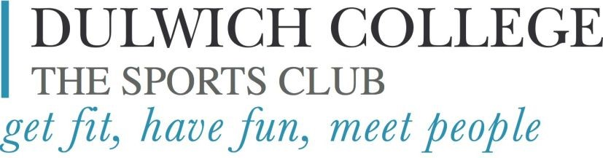

Programme Changes   
September-December 2025  
 *Please note the following planned variations to the published schedules:*

|  |  |
| --- | --- |
| **Date** | **Swimming Pool Opening Time** |
| Monday  22nd September  6th October  3rd November | **18:45pm** |
| Tuesday  23rd/30th September  14th October  25th November  9th December | **18:45pm**  **14th October/25th November 19:30pm Opening time** |
| Thursday  18th September  6th November | **18:45pm**  **6th November 19:30pm Opening time** |

**School Term Ends: 1st September 2025**

**School Term Starts 18th October 2025**

**Half Term**: 20.10.2025-03.11.2025

**DC Open Morning- 04.10.2025**

**Latest details of all programme changes may be viewed on the website live timetables.**